

**Semester Two Examination, 2021**

**Question Paper**

**ENGLISH**

**Year 12 Units 3&4**

**Time allowed for this paper**

Reading time before commencing work: ten minutes

Working time: three hours

**Materials required/recommended for this paper**

***To be provided by the supervisor***

This Question Paper  
Standard Answer Book

***To be provided by the candidate***

Standard items: pens (blue/black preferred), pencils (including coloured), sharpener,  
correction fluid/tape, eraser, ruler, highlighters

Special items: nil

**Important note to candidates**

No other items may be taken into the examination room. It is **your** responsibility to ensure that you do not have any unauthorised material. If you have any unauthorised material with you, hand it to the supervisor **before** reading any further.

**Structure of this paper**

|  |  |  |  |  |  |
| --- | --- | --- | --- | --- | --- |
| Section | Number of questions available | Number of questions to be answered | Suggested working time (minutes) | Marks available | Percentage of examination |
| Section One  Comprehending | 3 | 3 | 60 | 30 | 30 |
| Section Two  Responding | 6 | 1 | 60 | 40 | 40 |
| Section Three  Composing | 5 | 1 | 60 | 30 | 30 |
|  |  |  |  | **Total** | 100 |

**Instructions to candidates**

1. The rules for the conduct of examinations are detailed in the school handbook. Sitting this examination implies that you agree to abide by these rules.
2. Write your answers in the Standard Answer Book.
3. You must be careful to confine your answers to the specific question asked and to follow any instructions that are specified to a particular question.
4. You must not use texts from Section One to answer questions from Section Two.

Section One: Comprehending 30% (30 Marks)

In this section there are **three** texts and **three** questions. Answer **all** questions**.**

You are required to comprehend and analyse unseen written and visual texts and respond concisely in approximately 200–300 words for each question.

Suggested working time: 60 minutes.

Question 1 (10 marks)

Explain how Text 1 represents its perspectives and values to position an audience.

**Text 1**

Text 1 is an extract from the article ‘*Australia on the brink of deciding what it can become*’ by human rights lawyer Nyadol Nyuon. It was published in The Sydney Morning Herald in 2021.

War leaves you with a life lived at the mercy, often the charity, of others. A life waiting for grace. My mother, a widow raising seven children in a refugee camp, found that grace in her faith. And she tried to pass it on to us in songs – the songs my daughter now calls mine. I am struck by my four-year-old daughter’s choice of words: “Sing me your songs, Mama.” Born and raised here, she already has an emerging sense of what is hers and what is mine. And this includes her own sense of identity, and to me, that extends to her own sense of home. I know that neither my ‘Sudaneseness’ nor my ‘Australianness’ are transferable to her. What I see emerging in my daughter, is what I see in other young people of migrant backgrounds who were born or raised here. Like my daughter, they share the same skin colour as their immigrant parents, but it would be wrong to assume they share an identical sense of home. This country is home now. It is home both in its embrace and its rejections. I struggle to understand people who express fears of refugees and immigrants. I don’t understand their fear of the ‘foreigner’ because if they looked closely, just beyond the skin, they would see there is no ‘us’ and ‘them’. And, to see beyond that is how multiculturalism works.

By coming to a new country, you change. As I have. You learn to love that country. As I have. You learn to struggle to hold on to that love in the face of racism and discrimination. As I have. It is all in the process of becoming Australian. And through changing and becoming, there is room to expand who can be included in the concept of Australianness. Multiculturalism is an intuitive act of reciprocity and necessity. Reciprocity, because the overwhelming majority of refugees and other immigrants will never forget the generosity of this nation in taking them in. Necessity, because to make multiculturalism work is to make a life, a home. If this could be understood, it may address fears that immigrants will replace or undermine a way of life. The purpose of multiculturalism is to live with each other without fear. What sort of Australia could that be? I hope it is like the one my daughter and I create reading night-time stories. I sing her songs and read her books from another culture. There are no clashes of difference, but harmony that creates a soothing experience for her and an affirming moment for me. Of course, these are cherished memories, but what makes a nation? What this country decides to do now, in the face of current turmoils across the world and in response to demands by First Nation Peoples, will become our legacy, our inheritance for the future.

Question 2 (10 marks)

Compare the context of Text 1 and Text 2 and the way that empathy is generated.

**Text 2**

A copy of the book cover *Do Something for Nothing*, by British author Joshua Coombes, 2021.

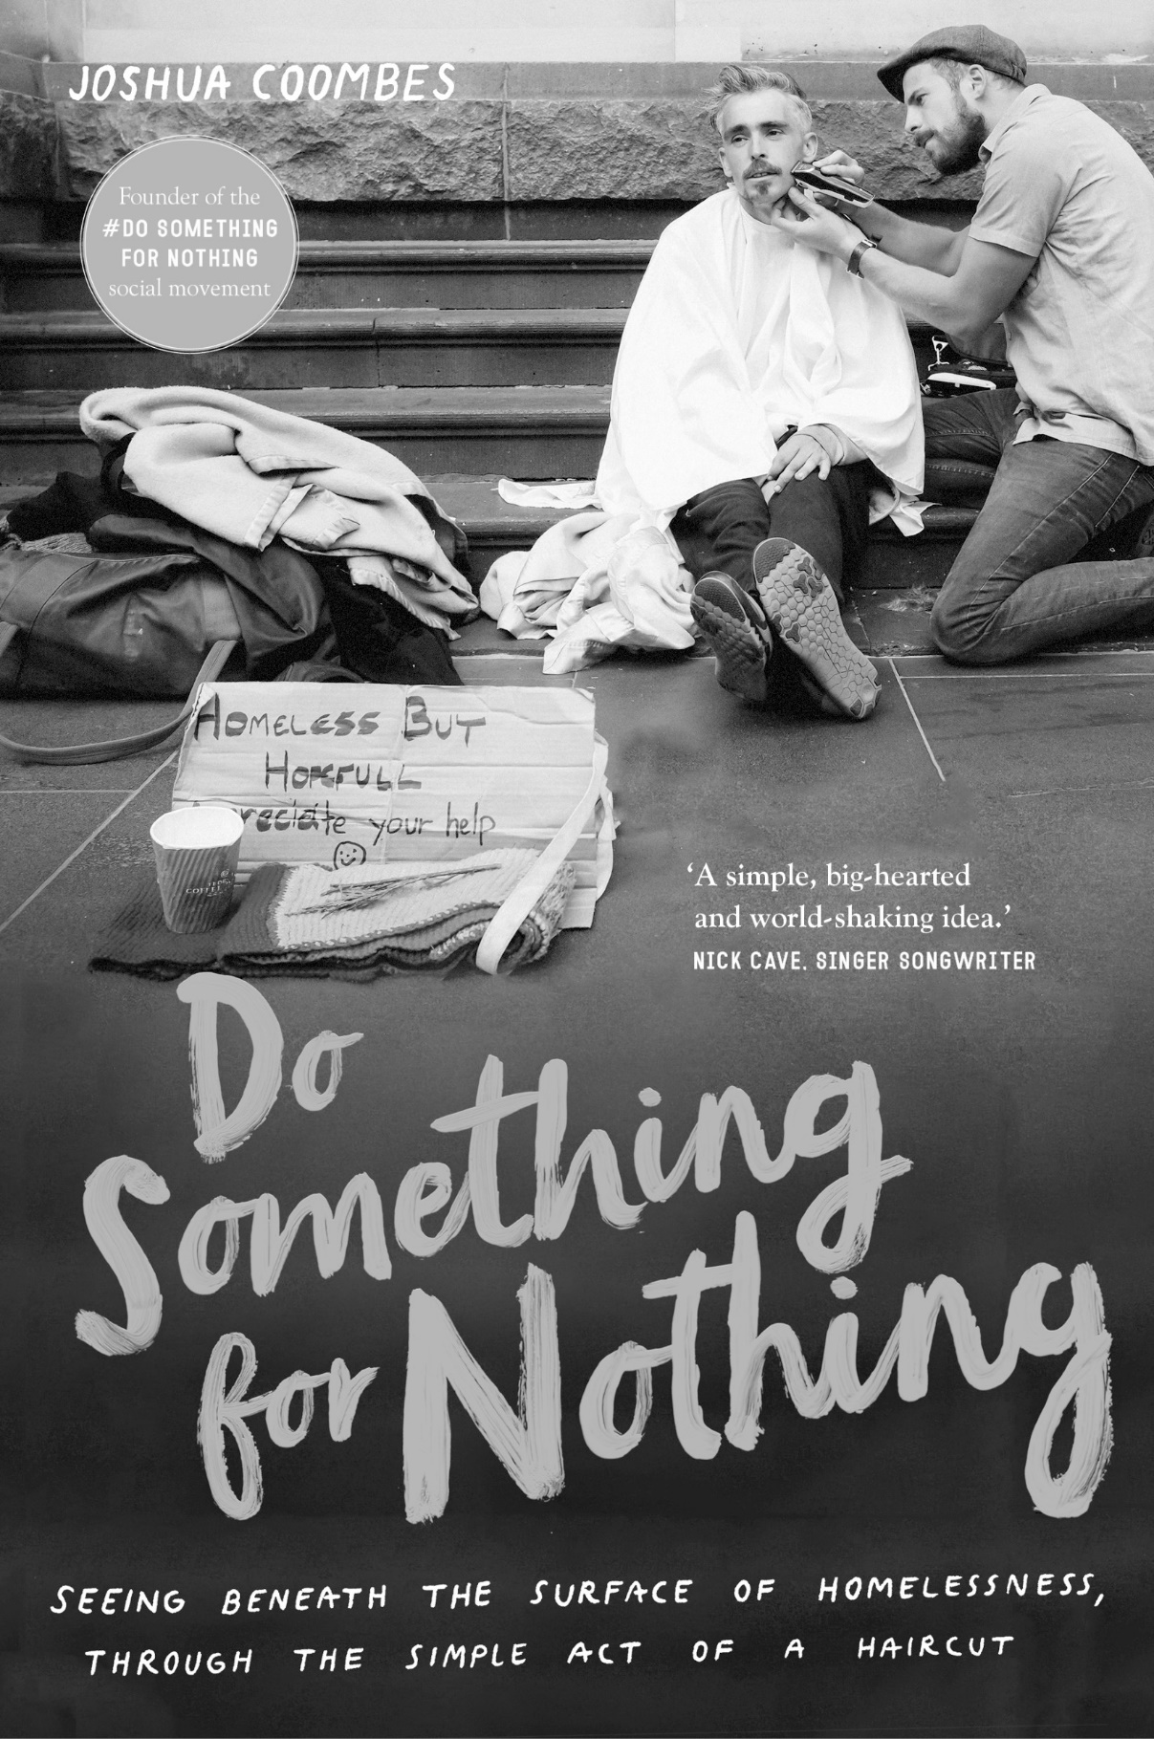

Question 3 (10 marks)

Evaluate how voice and point of view is persuasive for an audience in Text 3.

**Text 3**

Text 3 is an extract from the blog ‘*The Big Red Run: 250km of sheer desert endurance*’ by Cathy Finch. It was published in Australian Traveller in 2014.

If you’ve ever stood, alone, in the vastness of an Australian desert, then you’d be familiar with the extraordinariness of its silence. You’re in the middle of bloody nowhere, after all, and there is a sense of great nothingness in all that vastness. But there is also an unshakeable sense of power. It is one thing to spend a few days within this space from the safety of a car or tour bus. It is quite another to arm yourself with food, water and a GPS and head out, on foot, into that silence. Yet that’s precisely what I did. The Big Red Run is just that: an organised run (or walk) through the endless landscape of western Queensland’s outback, where, over six days, participants navigate across 250 kilometres of some of Australia’s most beautiful, brutal lands.

Though there are plenty of superhuman runners who take part in this event – the kind who’d consider my entire week’s exercise a morning warm-up – there are also a surprising amount of ‘normals’ here. Ordinary Aussies who, like me, are here because how often do you get to explore your physical and mental limits, sleep under the stars, swap stories around the campfire, be inspired by motivational speakers, raise funds for a worthwhile cause, and above all, connect intimately with Mother Earth? If it still sounds like a crazy undertaking … well, it is! But as ‘ordinary’ Australian and founder Greg Donovan says, “Nothing significant is ever achieved from within one’s comfort zone” – and he has a point. Donovan founded the event as a means of fundraising for his son’s Type 1 Diabetes and he pushes us to get ‘uncomfortable’, too.

There’s a sense of goodwill from the get-go. All runners are required to fundraise $1000 before they can run, along with a sense of journey, since everyone has already trekked to Birdsville, just to be here. On arrival we’re checked to ensure we’ve brought enough food and water, as well as wet and cold weather gear, a first aid kit, whistle, emergency blanket and compass – and they’re strict about it. Though we’re here for fun, safety is paramount, and to that end we’re also issued with a course map and GPS tracker, which not only has an emergency alarm button, but also tracks you to alert supervisors if you stop moving for too long. Next thing you know, we’re at the starting line, imbued with all the excitement and camaraderie of a festive gathering.

**End of Section One**

**This page has been left blank intentionally**

**Section Two: Responding 40% (40 Marks)**

In this section there are **six** questions. Answer **one** question.

Your response should demonstrate your analytical and critical thinking skills with reference to  
any text or text type you have studied.

Suggested working time: 60 minutes.

Question 4 (40 marks)

Discuss how a text’s innovative style or adaptation reveals new perspectives in the way a story is told.

Question 5 (40 marks)

Compare the way two texts represent an issue and challenge audience assumptions of identity.

Question 6 (40 marks)

Discuss how conventions shape ideas in a text that is fundamentally about hope and resilience.

Question 7 (40 marks)

Compare two texts with similar genre themes that reflect different cultural contexts and audiences.

Question 8 (40 marks)

Consider the impact of voice and narrative point of view in a text that raises uncomfortable questions.

Question 9 (40 marks)

Evaluate how a multimodal text generates talking points and expands your understanding of others.

**End of Section Two**

**This page has been left blank intentionally**

**Section Three: Composing 30% (30 marks)**

In this section there are **five** questions. Answer **one** question.

You are required to demonstrate writing skills by choosing a form of writing appropriate to a specific audience, context and purpose.

Suggested working time: 60 minutes.

Question 10 (30 marks)

We need controversy to create conversations and build bridges.  
  
Write a persuasive text that conveys opinion with this statement in mind.

Question 11 (30 marks)

Sometimes, out of the blue, you catch a glimpse of the future.  
  
In a form of your choice write a text that creates a context for this statement.

Question 12 (30 marks)

Create an imaginative text that draws from the setting below to sustain a narrative voice.

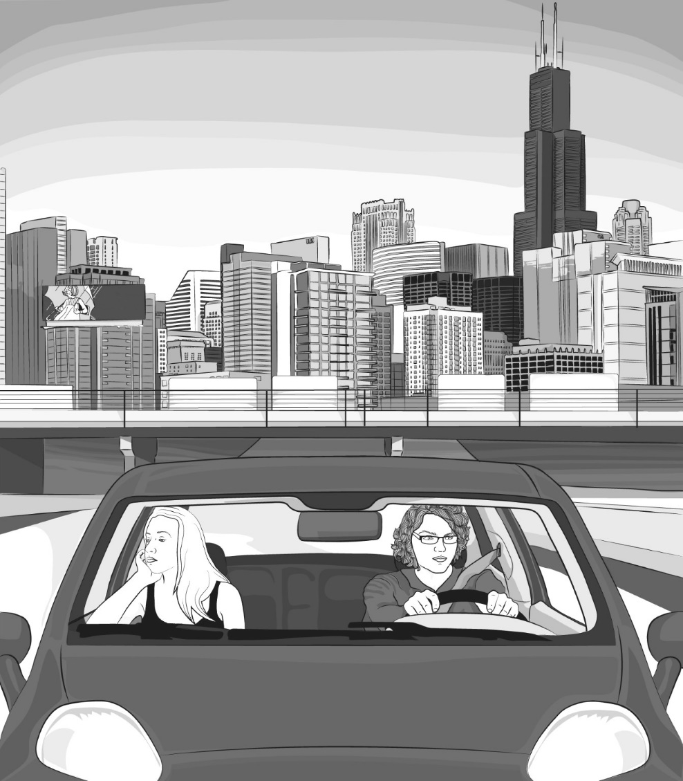

Question 13 (30 marks)

‘Do you feel a seismic shift around us? A fresh, vocal generation is rising strong.’  
  
Write an interpretive text that represents ideas suggested by this quote.

Question 14 (30 marks)

In a form of your choice, compose a text that is inspired by the mood of this image.

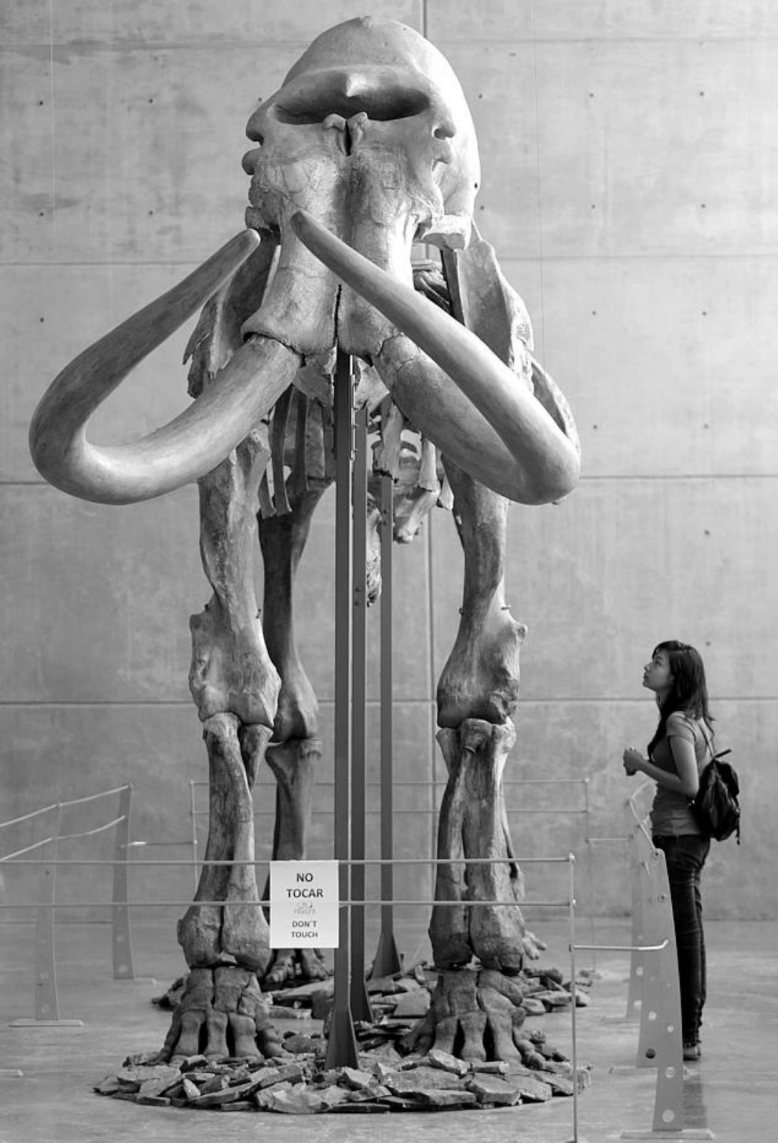

**ACKNOWLEDGEMENTS**

**Question 1** Nyuon, N. Edited extract from the article ‘*Australia on the brink of deciding what it can become*’. The Sydney Morning Herald (2021).

**Question 2** Coombes, J. Copy of Book cover: *Do Something for Nothing*. Murdoch Books (2021).

**Question 3** Finch, C. Blog extract ‘*The Big Red Run: 250km of sheer desert endurance*’. Australian Traveller website (2014).

**Question 12** Radtke, K. Illustration by sourced from: https://floodmagazine.com/44330/breaking-kristen-radtke/.

**Question 13** Gemmell, N. Quote. Sourced from the article ‘*There’s a changing of the guard – and we’re on notice*’. The Australian (2021).

**Question 14** Photographic image (AFP) sourced from: https://www.news.com.au.

© 2021 WA Exam Papers. Leeming Senior High School has a non-exclusive licence to copy and communicate this document for non-commercial, educational use within the school. No other copying, communication or use is permitted without the express written permission of WA Exam Papers. Some material in the exam has been copied (and communicated to you) in accordance with the Exam Copying Exception in Section 200(1A) of the Copyright Act. Any further reproduction or communication of this material by you may be the subject of copyright protection under the Act. Do not remove this notice. SN056-769-1.